**ASSIGNMENT 8**

Name: Imon Raj

Class: BCSE III

Roll: 002010501098

Section: A3

Subject: Computer Networks Lab Report

**PROBLEM STATEMENT: Implement any two protocols using TCP/UDP Socket as suitable. 1. FTP 2. DNS 3. Telnet**

**DESIGN:** This assignment is based on application layer protocols. Among the three mentioned, I have implemented FTP(File Transfer Protocol) and DNS(Domain Name System). I have used Java as my programming language and an Object-oriented approach.

* FTP (File Transfer Protocol) is a network protocol for transmitting files between computers over Transmission Control Protocol/Internet Protocol (TCP/IP) connections. Within the TCP/IP suite, FTP is considered an application layer protocol.

In an FTP transaction, the end user's computer is typically called the local host. The second computer involved in FTP is a remote host, which is usually a server. Both computers need to be connected via a network and configured properly to transfer files via FTP. Servers must be set up to run FTP services, and the client must have FTP software installed to access these services.

Although many file transfers can be conducted using Hypertext Transfer Protocol (HTTP) -- another protocol in the TCP/IP suite -- FTP is still commonly used to transfer files behind the scenes for other applications, such as banking services. It is also sometimes used to download new applications via web browsers.

* DNS stands for Domain Name System. It is a naming system that is used to identify devices across the internet. It is an application layer protocol and is used to map the domain names to the IP addresses.

The host requests for the IP address of a particular domain name to the DNS server and the IP address is returned to the host by the DNS server. The hierarchy of the resolution of the request is shown below.

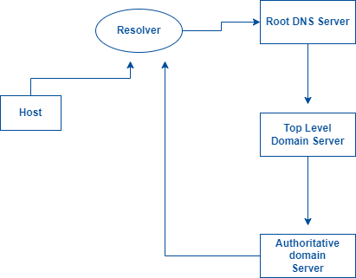

**IMPLEMENTATION:**

All Java codes are uploaded in the shared Drive folder.

I have used TCP socket of Java for the implementations. I have used library classes – **ServerSocket** and **Socket** for creating Client-Server system. For reading data from socket and writing data into socket, **DataInputStream**, **DataOutputStream** classes are used.

For FTP, I have developed GUI based application, similar to FTP clients like FileZilla. For GUI I have used **java.swing** library. Here Connection is created with remote FTP server and then file can be downloaded from server and uploaded(may be updated) to server.

For DNS, I have tried to use the iterative system. I have implemented the name resolution such that it can resolve domains with two levels.

.

**RESULTS & ANALYSIS:**

**FTP OUTPUT:**

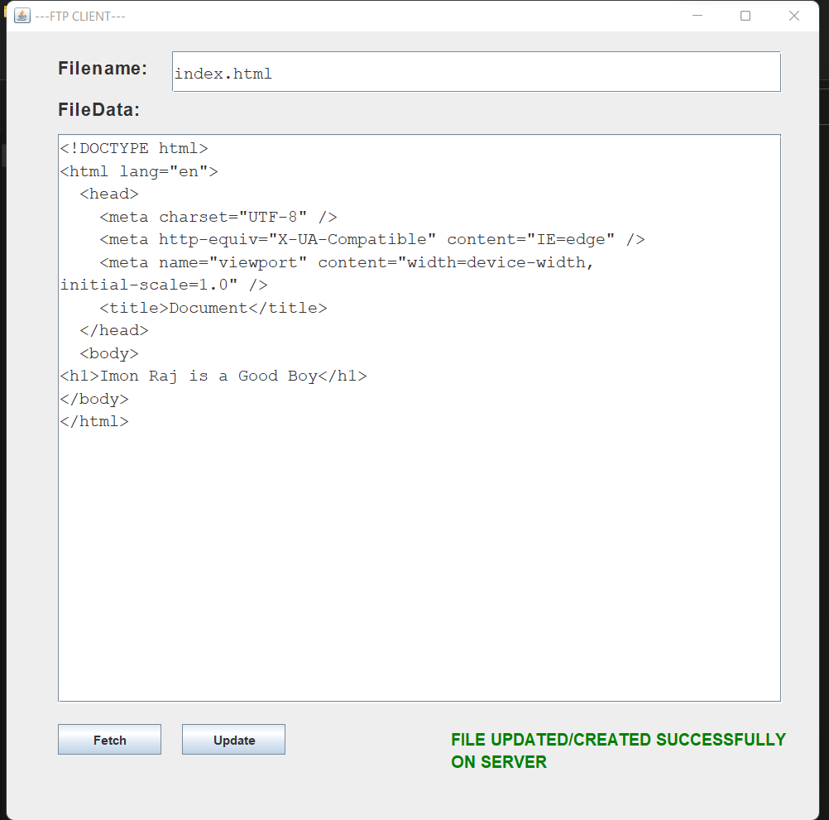

**DNS OUTPUT:**

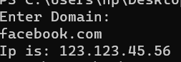

**COMMENTS:**

This program was interesting to implement. There is chance of improvement in case of DNS implementation. We can have functionalities to resolve domains with multiple levels.